**Free *SSL Register & download***

* Search google on free ssl certificate.

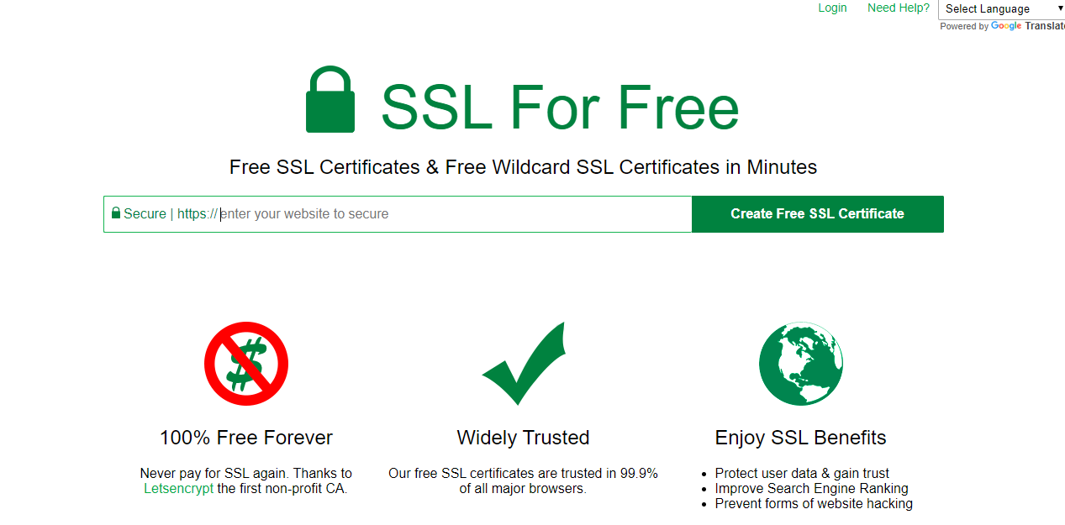

* Enter domain name & click on create free ssl certificate.

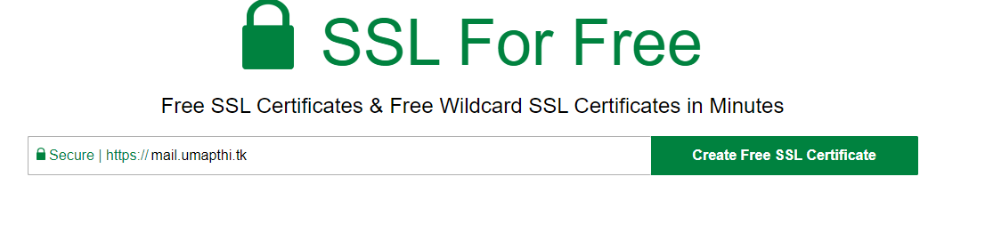

* Click on manual verification.

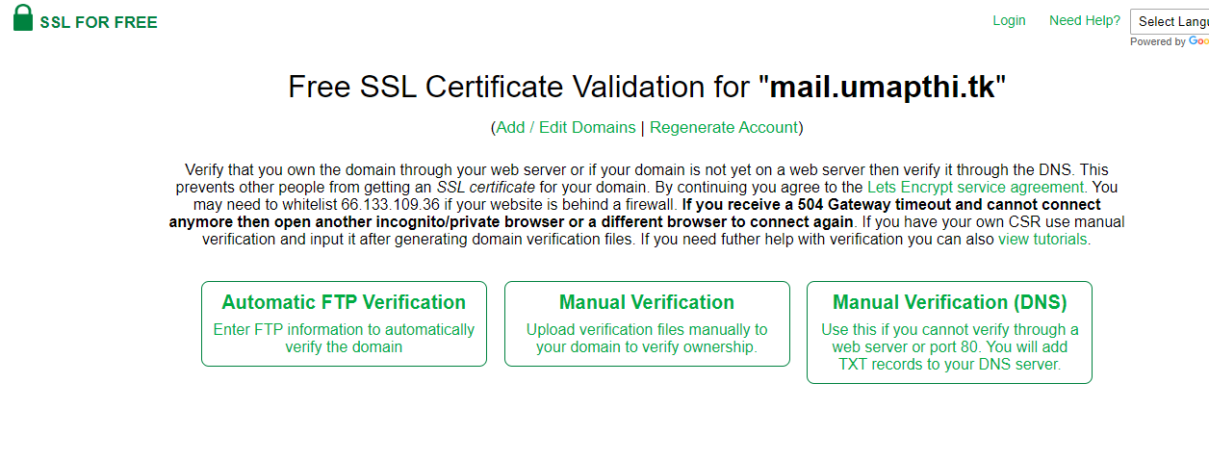

* Click on manually verify domain.

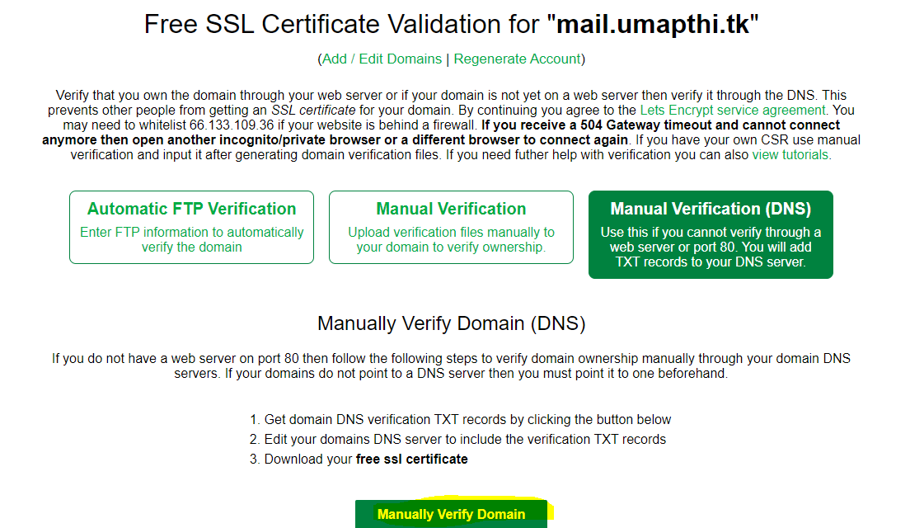

* We can copy the update DNS records

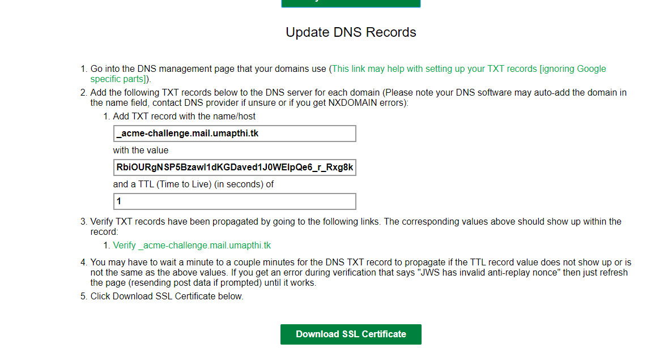

* And paste into our domain site, login freenom click on my domains.

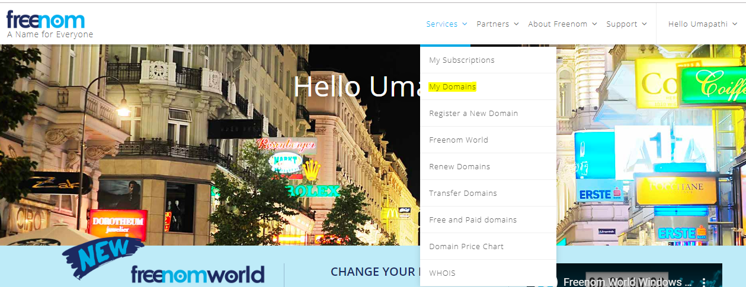

* Select domain, click on manage domain

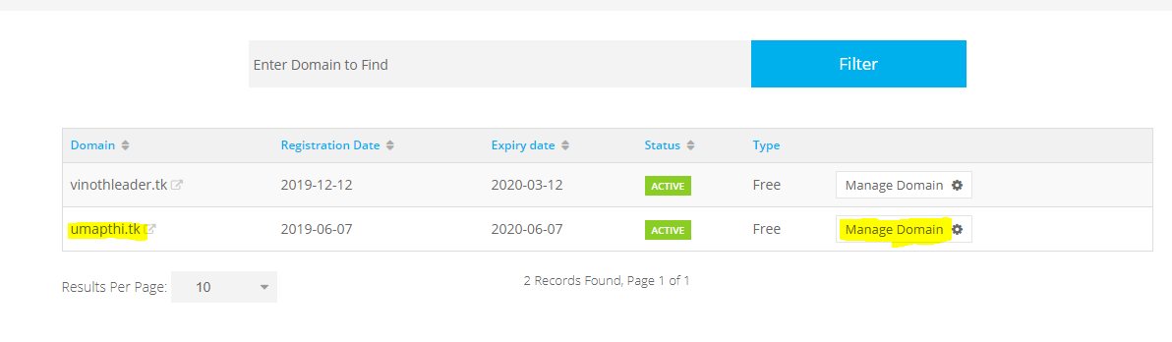

* After that click on manage freenom DNS option,

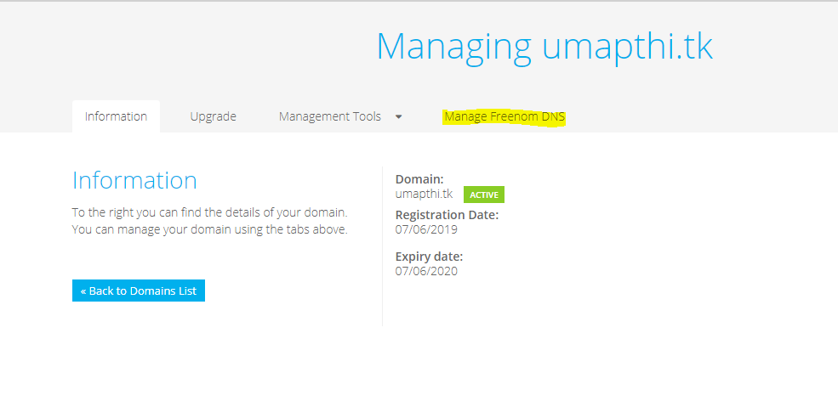

* Add the ssl details here, click on save changes.

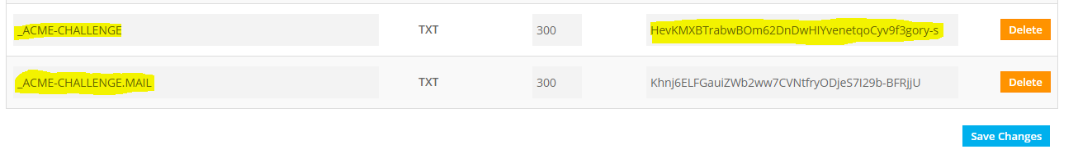

* After some time, we can click on verify the ssl working.

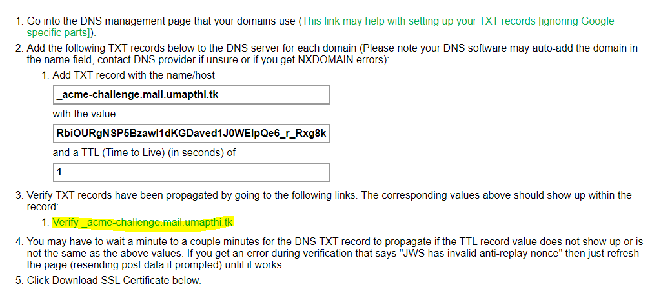

* Know it’s working fine, we can click on download the ssl certificate.

